SCOTS CHURCH ADELAIDE
UNITING CHURCH IN AUSTRALIA
Kaurna Country 237 North Terrace
Adelaide, South Australia

Scots Church Adelaide is a welcoming,
inclusive, and worshipping community of God,
committed to justice, learning and care,
anticipating a world transformed by the love of God.

Sunday 14th April 2024
Preacher: Rev Jill Lienert
Liturgist: Dr Mari Yu
Organist: Mr Jeffrey Kong
Reader: Mr Ho Lee

Scots Church Adelaide acknowledges that we gather on Kaurna Country, and we pay respect to Elders past, present and emerging. We recognise and respect their culture, beliefs and relationship with the land.
WE GATHER TO CELEBRATE
THE PRESENCE OF DIVINE MYSTERY

A warm welcome is extended to all.
Your presence both enriches us
and this time of celebration together.

An asterisk * indicates you are invited to stand as you are able. You are invited to speak the words in bold italics.
Helpful instructions are in italics
Our worship service follows a classic pattern. For those of us who might be unfamiliar with this pattern, sentences in this font and in brackets briefly explain the parts of the service.

If you require the hearing loop please sit in middle
of the centre pews

GATHERING
(The meditation and prelude are intended to help you set aside the stresses of our lives and prepare for worship.)

Meditation

In the Easter Season (6 Sundays following Easter Day) many traditions do not have a Prayer of Confession. This is what we will do today. How does it feel? What difference does it make to your worship experience?

Prelude

*Processing of the Bible
Please stand, as you are able, for the processing of the Bible.

Welcome

Call to Worship
(We start by reminding ourselves that we are here to worship God together.)

Opening Prayer
(This prayer acknowledges that God is with us and helps us experience God’s presence. The hymn continues the praise.)
Loving God, when we are frightened and filled with doubts…
Open us to the Gospel of peace.
When we think we understand everything and our minds are closed to new teachings …
Open us to the Gospel of peace.
When we do not understand and our fears turn into anger or mistrust …
Open us to the Gospel of peace.
When we want to hide behind laws, regulations and traditions that can hurt and exclude …
Open us to the Gospel of peace.
As the risen Christ came to be with the disciples and show them new possibilities
Open us to the Gospel of peace.
Come, Holy Spirit, come. Amen.

*Hymn TiS 147 To God be the Glory
WE LISTEN FOR WHAT THE SPIRIT
IS SAYING TO THE CHURCH TODAY

(We want to live in the way God wants us to live. First, we pray that God might help us understand what that means, then we listen to a part of the Bible, and finally, a message or sermon exploring what those words might mean for us today. The hymn often picks up on some theme from the Bible reading.)

Prayer for Illumination

An Introduction to the Readings

The Good News for Today
Luke 24: 36b-48 (page 69)

In sacred words of old,
we have heard the Spirit speak anew.

*Hymn TiS 233 I will sing the wondrous story

Sermon

Reflection time
(A moment, aided by music, to reflect on what we have heard and said in our worship together.)
Jeffrey Kong will play Bach’s Ich ruf zu dir, Herr Jesu Christ (I Call on Thee Lord) on piano.

Affirmation
On a hill, we understand there was a cross.
In the garden, we guess there was a tomb.
In the tomb, we gather there was a body,
But in the morning, we know there was a resurrection!

Tell it to the world!
Tell it to Africa!
Tell it to Afghanistan!
Tell it to Myanmar!
Tell it to Ukraine!
Tell it to Gaza!
Tell it to Israel!
Tell it to the night-lit streets of Adelaide!
Tell it to the families destroyed by violence and manipulation!
Tell it to homeless folk who sleep right in our midst!
Tell it to the lonely who rarely receive visitors!
Tell it to the disheartened who cannot remember who they are!
Tell it to the students struggling with exams and assignment deadlines!
Tell it to our community!
And tell it again!

On a hill, we understand there was a cross.
In the garden, we guess there was a tomb.
In the tomb, we gather there was a body,
But in the morning, we know there was a resurrection!

*Hymn TiS 245 We have a gospel to proclaim

WE RESPOND IN FAITH
(In this part of the service we commit ourselves to live out the message of love that we have heard.)

Prayers of the People
(God calls us to love and care for each other. In this prayer, we remember situations of need in the world. It closes with the Lord’s Prayer, which was taught by Jesus to his disciples and is used by all Christians.)

Dear God, because our lives have been touched by your presence, we claim your love with gratitude and place beside us all those in need of love and justice today…

For we would be your love in the world, born of the hands that reached out and touched you so long ago as they recognised their God and Saviour with them forever. Make us people who have truly come near to their god. Amen.

(The Lord’s Prayer is inside the back cover of the hymnal)
Invitation to the Offering
(One practical way of responding is to contribute money which is used to help others who are in need.)

Our offering will now be received.

*Prayer of Dedication
(We offer the money to God and pray that it might be used wisely.)

Life and Ministry of the Congregation
(We mention some of the things that are happening in our community, including the practical ways we can respond to God’s love for us, by loving our neighbour.)

*Hymn TiS 376 I know that my Redeemer lives

WE DEPART IN PEACE
TO LOVE AND SERVE

*Commissioning
(At the end of the service, we prepare to go back to our daily lives. The Commissioning reminds us how we are to live in the world. The Blessing reassures us that God is with us in our daily lives.)

*Blessing
And may Christ surround our days with peace,
The Holy Spirit give courage in our choosing
And the Creator bless us in every moment. Amen.

*Choral Amen TiS 783(ii)

Postlude and *Processing of the Bible
Please stand as you are able for the processing of the Bible.
The postlude is an opportunity for quiet reflection. Please resume you seat until the postlude has ended.

Closing

Sources used in worship today include Seasons of the Spirit, and Words for Worship. Image: unsplash.com. Music reproduced with permission licenses #604419-A, OneLicense, and #496838&#352810, CCLI.
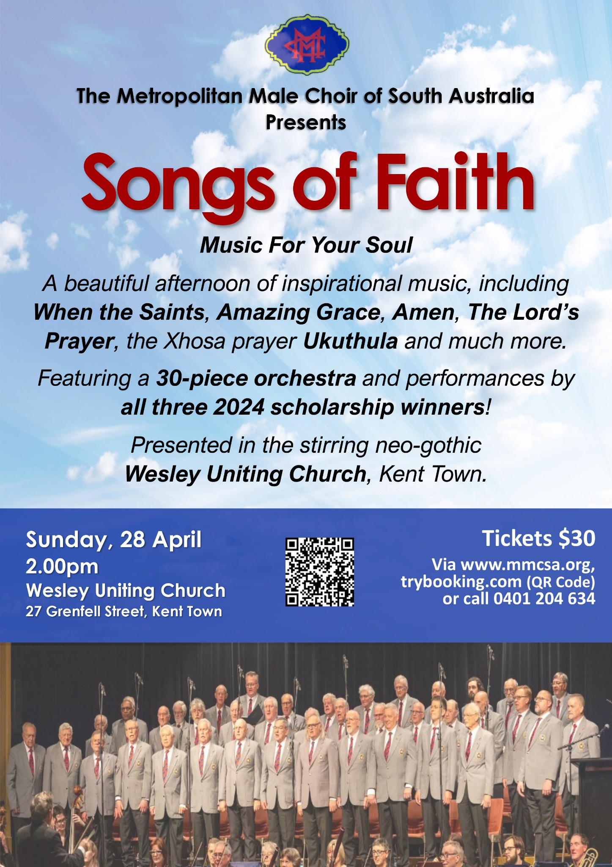

About Scots Church Adelaide

Scots Church was opened in 1851 by local supporters of the Free Church, a reform movement in the Church of Scotland that opposed political control of the church and engaged with the social changes of the 1800s, including industrialisation and urbanisation. The church originally was named after the leader of the movement, Thomas Chalmers. In 1865 Chalmers Free Church joined with congregations of the Church of Scotland, the United Presbyterians and the Free Church to form the Presbyterian Church of South Australia.

In 1929, the congregation amalgamated with Flinders St Presbyterian Church and took the name Scots Church. After the Flinders St church was demolished items such as the organ, windows and plaques, were placed in Scots Church, and the stonework re-used as facing for the office block. In 1977 Scots Church joined the Uniting Church in Australia

Over the years, the congregation has supported many social initiatives around Adelaide. Today Scots proudly continues in its commitment to the city community as a neighbour and place open to all. We host several community organizations, including the SA Jazz Archive and The Big Issue. Our facilities are available for use by other community groups.

The building is the second oldest church still standing in the city. The current ministers are Rev Paul Turley, Minister of the Congregation, and Rev Jill Lienert, Minister for Community Connections. Worship services are held at 10.30am each Sunday.

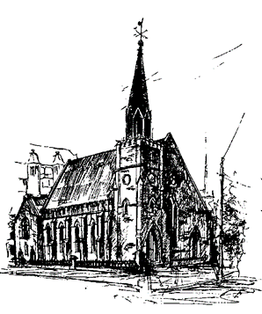

SCOTS CHURCH ADELAIDE
Uniting Church in Australia
Kaurna Country 237 North Terrace, Adelaide
Ministers: Rev Paul Turley, Rev Jill Lienert
Phone 8223 1505 www.scotschurch.org
www.facebook.com/scotschurchadelaide

