Sunday Worship

Scots Church Adelaide

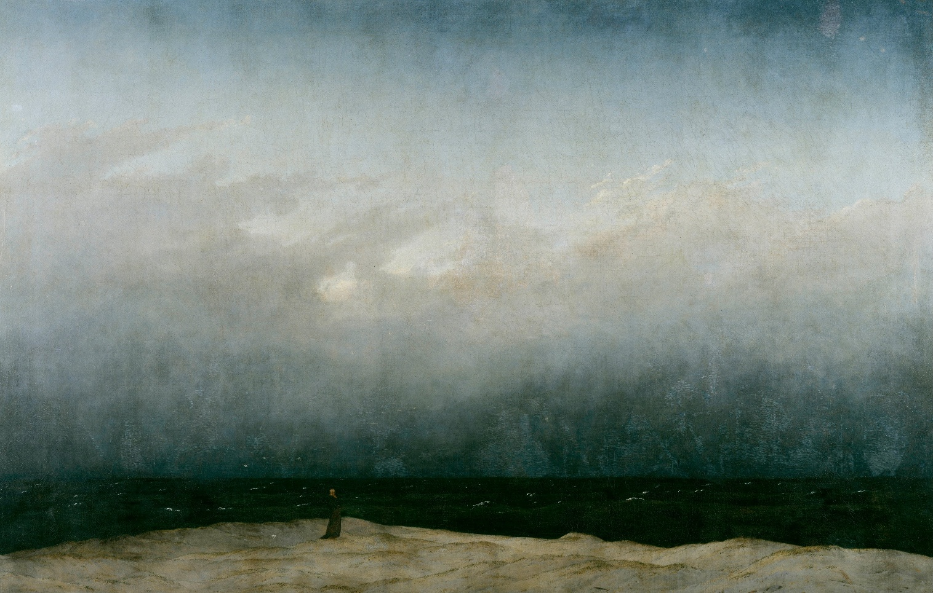

Sunday 21st June 2026

Scots Church Adelaide is a welcoming,
inclusive, and worshipping community of God,
committed to justice, learning and care,
anticipating a world transformed by the love of God.

Scots Church Adelaide acknowledges that we gather on Kaurna Country, and we pay respect to Elders past, present and emerging. We recognise and respect their culture, beliefs and relationship with the land.

Welcome

An asterisk * indicates that we stand as we are able.
We are invited to speak the words in bold italics.
Helpful instructions and explanations are in italics.
If you require the hearing loop, please sit in the middle of the centre pews.

Meditation

In Caspar David Friedrich’s The Monk by the Sea (1810), a man stands in an empty landscape looking out to sea. The ocean and the sky are vast and unknowable—perhaps a storm is coming—they take no account of the small, solitary figure on the shore. The man is a monk, someone well-schooled and practised in exploring the mystery of existence, the divine, and the infinite. Facing the enormous reality of elemental nature and human vulnerability, the monk might well be recalling the words of the psalmist: What are human beings that you are mindful of them, mortals that you care for them? (Psalm 8:4) This human being stands, head bare, hands clasped in contemplation, experiencing, without flinching or turning away, all that is.

Prelude

The music of the prelude invites us to quieten our busy minds and prepare to worship.

*Processing of the Bible

We stand and together bring the Bible to the centre of our worship service,
expecting to learn and be inspired.

Lighting the Candle

The candle’s flame represents the presence of God with us now and always.

Then God said, “Let there be light,” and there was light.
Light shining in the darkness

The light of creation
The light of the world

(from the Book of Genesis: 10th–5th Century BCE
and the Gospel of John: late 1st century CE)

Call to Worship

We remind ourselves that we are here to worship God together.

Christ our true and only Light:
receive our prayers and songs,
and illumine the secrets of our hearts
with your healing goodness,
that no evil desires may possess us
who are made new
in the light of your
heavenly grace.
Amen.

(from the Gelasian Sacramentary: early 8th century CE)

*A Hymn of Praise 238 Christ is the world’s true light

1. Christ is the world's true light,
its captain of salvation,
the day-star clear and bright,
desire of every nation;
new life, new hope awakes
for all who own his sway:
freedom her bondage breaks,
and night is turned to day.

2. In Christ all races meet,
their ancient feuds forgetting,
the whole round world complete,
from sunrise to its setting:
when Christ is throned as Lord
all shall forsake their fear,
to ploughshare beat the sword,
to pruning-hook the spear.
3. One Lord, in one great name
unite us all who own you;
cast out our pride and shame
that hinder to enthrone you;
the world has waited long,
has travailed long in pain;
to heal its ancient wrong,
come, Prince of Peace, and reign.

Psalm 100

The Hebrew Psalms are an ancient collection of poems long used in Christian worship.

Make a joyful noise to the Lord, all the earth.
Worship the Lord with gladness;

come into God’s presence with singing.
Know that the Lord is God.
It is God who made us,
we are God’s people, and the sheep of God’s pasture.

Enter God’s gates with thanksgiving,
and God’s courts with praise.

Give thanks to God, bless God’s name.
For the Lord is good;
God’s steadfast love endures forever,
and God’s faithfulness to all generations.

(Psalm 100: 10th–5th Century BCE)

Prayer

This prayer acknowledges that God is with us and helps us experience God’s presence.
God is good.
For life and health, for healing and well-being,
we thank you, God.

God is great.
For strength to help, for ability to make things better for others,
we thank you, God.

God is kind.
For compassion that moves us, for empathy that allows us to reach out,
we thank you, God.

God is our deliverer.
For freedom to be and do, for wisdom to choose the right and godly things to do,
we thank you, God.

God is patient.
For living in community, for grace in diversity,
we thank you, God.

God is our foundation.
For our histories, for our heritage, for our race and ethnicities,
we thank you, God.

God is our Creator.
For our shared faith, for our diverse faith journeys, for our various expressions, for our distinct tastes and preferences,
we thank you, God, that in you, we are one.

Thanks be to God!

Amen.
(United Church of Canada: 21st century CE)

Prayer of Confession

We are made in the image of God, but so often do not fully live this truth. We do much to damage ourselves and each other. In confession, we acknowledge these hard truths and open ourselves to God’s forgiveness, which comes to us abundantly.

Before God, we confess in silence:

Lord Jesus Christ, my Redeemer, my mercy, my salvation:
I praise you and give you thanks, though even these gifts of
thanks fail to live up to your goodness, which deserves far
greater devotion. They are much too lean for the full beauty
of your affection. Yet I will give some sort of praise, some sort
of thanks. Though my thanks will not be what they should,
I will give as much as my soul is able.
Hope of my heart, strength of my soul, helper of my weakness:
Let your powerful kindness complete what I am trying
to accomplish despite my tepid weakness. Oh my life, the
end for which I aim even though I have not yet loved you
as I should, please let my longing for you match what my
love should be.
Amen.
(Anslem of Canterbury: 11th century CE)

Assurance of Pardon and Renewal

God is the great shepherd of the sheep.
God leads us in safety and abundance.
Friends, our cup is full to overflowing!
We are loved.
We are forgiven.
We are made whole.
Thanks be to God.

(Uniting Church in Australia: 21st Century CE)

*A Hymn of Thanks 76 I to the hills will lift my eyes

1. I to the hills will lift my eyes:
where shall I find my help?
My help comes only from the Lord
who made the earth and heaven.
2. Your foot he’ll not let slide, nor will
your guardian even sleep:
the one who guards his people still,
he slumbers not, nor sleeps.
3. The Lord will be a shield and shade
with him at your right hand
no harm will come from sun by day
nor from the moon by night.
4. The Lord will keep you from all harm:
will guard your very life,
preserve your going out and in
now and forevermore.

WE LISTEN FOR WHAT GOD IS SAYING TO US TODAY

In this part of our worship service, we pray that God might help us understand what we hear,
we listen to parts of the Bible, and a message exploring what those words might mean for us today.

Prayer for Illumination

May these ancient texts be a lamp to our feet
and a light to our path.

(Psalm 119: 10th–5th Century BCE)

An Introduction to the Bible readings

The Psalm for the day

The Psalms express the full range of human emotions before God: joy, sorrow, praise, anger, trust, and repentance. We read the text on the screen in call and response.

Psalm 86:1-10, 16-17

Incline your ear, O Lord, and answer me,
for I am poor and needy.

Preserve my life, for I am devoted to you; save your servant who trusts in you. You are my God.

Be gracious to me, O Lord,
for to you do I cry all day long.

Gladden the soul of your servant, for to you, O Lord, I lift up my soul.

For you, O Lord, are good and forgiving,
abounding in steadfast love to all who call on you.

Give ear, O Lord, to my prayer; listen to my cry of supplication.

In the day of my trouble I call on you,
for you will answer me.

There is none like you among the gods, O Lord, nor are there any works like yours.

All the nations you have made shall come
and bow down before you, O Lord,

And shall glorify your name.

For you are great and do wondrous things;

You alone are God.
Turn to me and be gracious to me;
give your strength to your servant;
save the child of your serving-maid.

Show me a sign of your favour, so that those who hate me may see it and be put to shame, because you, Lord, have helped me and comforted me.

The Good News for today

Jeremiah 20:7-13
⁷ O Lord, you have enticed me,
and I was enticed;
you have overpowered me,
and you have prevailed.
I have become a laughingstock all day long;
everyone mocks me.
⁸ For whenever I speak, I must cry out;
I must shout, “Violence and destruction!”
For the word of the Lord has become for me
a reproach and derision all day long.
⁹ If I say, “I will not mention him
or speak any more in his name,”
then within me there is something like a burning fire
shut up in my bones;
I am weary with holding it in,
and I cannot.
¹⁰ For I hear many whispering:
“Terror is all around!
Denounce him! Let us denounce him!”
All my close friends
are watching for me to stumble.
“Perhaps he can be enticed,
and we can prevail against him
and take our revenge on him.”
¹¹ But the Lord is with me like a terrifying warrior;
therefore my persecutors will stumble,
and they will not prevail.
They will be greatly shamed,
for they will not succeed.
Their eternal dishonor
will never be forgotten.
¹² O Lord of hosts, you test the righteous;
you see the heart and the mind;
let me see your retribution upon them,
for to you I have committed my cause.
¹³ Sing to the Lord;
praise the Lord!
For he has delivered the life of the needy
from the hands of evildoers.

Matthew 10:24-39
²⁴ “A disciple is not above the teacher nor a slave above the master; ²⁵ it is enough for the disciple to be like the teacher and the slave like the master. If they have called the master of the house Beelzebul, how much more will they malign those of his household!
²⁶ “So have no fear of them, for nothing is covered up that will not be uncovered and nothing secret that will not become known. ²⁷ What I say to you in the dark, tell in the light, and what you hear whispered, proclaim from the housetops. ²⁸ Do not fear those who kill the body but cannot kill the soul; rather, fear the one who can destroy both soul and body in hell. ²⁹ Are not two sparrows sold for a penny? Yet not one of them will fall to the ground apart from your Father. ³⁰ And even the hairs of your head are all counted. ³¹ So do not be afraid; you are of more value than many sparrows.
³² “Everyone, therefore, who acknowledges me before others, I also will acknowledge before my Father in heaven, ³³ but whoever denies me before others, I also will deny before my Father in heaven.
³⁴ “Do not think that I have come to bring peace to the earth; I have not come to bring peace but a sword.
³⁵ For I have come to set a man against his father,
and a daughter against her mother,
and a daughter-in-law against her mother-in-law,
³⁶ and one’s foes will be members of one’s own household.
³⁷ “Whoever loves father or mother more than me is not worthy of me, and whoever loves son or daughter more than me is not worthy of me, ³⁸ and whoever does not take up the cross and follow me is not worthy of me. ³⁹ Those who find their life will lose it, and those who lose their life for my sake will find it.

In sacred words of old,
we have heard the Spirit speak anew.

Sermon

Reflection:

A moment, aided by music, to reflect on what we have heard and said in our worship together.

WE RESPOND IN FAITH

In this part of our worship service, we commit ourselves to live out the message of love that we have heard.

*A Hymn of Dedication 459 In Christ there is no east or west

1. In Christ there is no east or west,
in him no south or north,
but one great fellowship of love
throughout the whole wide earth.
2. In Christ shall true hearts everywhere
their high communion find,
his service is the golden cord,
close-binding humankind.
3. Join hands, then, members of the faith,
whate’er your race may be;
who serves my Father as his child
is surely kin to me.
4. In Christ now meet both east and west,
in him meet south and north,
all Christlike souls are one in him
throughout the whole wide earth.

Prayers of the People

We pray for our world, and we pray the prayer that Jesus taught to his disciples.

Let us pray:

Loving Creator,
Source of all life and breath,
we are your people;
guide us in the way of peace.

May we walk in the path of love, justice, and mercy,
turning away from the ways that harm ourselves and others.

God of daily bread,
feed those who hunger today—
in body, in spirit, and in hope.
May we share our resources with generosity,
challenging systems that deny food and dignity.

God of peace,
guide leaders and communities to choose nonviolence,
to work for justice, and to protect the earth,
so that your reign of peace may grow in every land.

God of forgiveness,
You forgive; may we be communities of forgiveness.
May we seek repair where harm has been done,
and find freedom in letting go of resentment.

God of deliverance,
free us from the idols of greed, power, and fear,
and from the evils that destroy community and creation.
Help us to resist all that dehumanises and divides.

God of light,
help us to be your presence in the world,
to encourage the fainthearted, to lift up the oppressed,
and to stand in solidarity with the marginalised.

Loving God,
we pray these things, trusting in your Spirit
who breathes through us, among us, and beyond us,
renewing hope in all creation.
Amen.

(Uniting Church in Australia: 21st century CE)

The Lord’s Prayer

Let us pray:

Our Father in Heaven
hallowed be your name,
your kingdom come,
your will be done,
on earth as in heaven.
Give us today our daily bread.
Forgive us our sins,
as we forgive those who sin against us.
Save us from the time of trial
and deliver us from evil.
For the kingdom, the power, and the glory
are yours, now and forever. Amen.
(Matthew 6:9-13: 1st century CE)
Invitation to the Offering

One practical way of responding to God’s love is to contribute money to help others in need.

God gives us all things.
Let us rejoice in the joy of giving.

Our offering will now be received.

*Prayer of Dedication

We bring our offerings to God and pray that they might be used wisely.

Receive these gifts, God of all giving.
They, like all that is good,
come from you
and now go out into your world.
Amen.

*A Hymn of Commissioning 457 the church’s one foundation

1 The church's one foundation
is Jesus Christ her Lord:
she is his new creation
by water and the word;
from heaven he came and sought her
to be his holy bride;
with his own blood he bought her,
and for her life he died.

2 Elect from every nation
yet one o'er all the earth,
her charter of salvation,
one Lord, one faith, one birth;
one holy name she blesses,
partakes one holy food,
and to one hope she presses
with every grace endued.

3 Though with a scornful wonder
the world sees her oppressed,
by schisms rent asunder,
by heresies distressed,
yet saints their watch are keeping,
their cry goes up, 'How long?'
and soon the night of weeping
shall be the morn of song.

4 Through toil and tribulation
and tumult of her war
she waits the consummation
of peace for evermore,
till with the vision glorious
her longing eyes are blessed,
and the great church victorious
shall be the church at rest.

5 Yet she on earth has union
with God the Three in One,
and mystic sweet communion
with those whose rest is won.
O happy ones and holy!
Lord, give to us the grace
like them, the meek and lowly,
in heaven to seek your face.

LIFE AND MINISTRY OF OUR COMMUNITY

We share news about our life together in community.

WE GO IN FAITH

Our worship together now moves from this service and this place out into our hours and our days.

We continue to make community amongst us by hearing the Blessing, passing the peace and moving to the hall to share tea, coffee, and conversation.

If you are visiting with us, we invite you to join us this morning.
If you need to go, we understand.

You may wish to sign our visitors’ book as you leave.

*Affirmation

An affirmation expresses things we believe are true. We speak it aloud
to remind ourselves of our calling and to embed it in our lives.

We believe
that every human being is made in the image and likeness of God
and possesses a dignity and value which can never be taken away.

We believe
that as children of the one God
we are one family with mutual responsibility for each other

(Cardinal Basil Hume: late 20th century CE)

*Passing the Peace

We send each other out into our day in peace.

Peace be with you. And also with you

*Blessing

The Blessing reassures us that God is with us.

Go forth into the world in peace;
be of good courage;
hold fast that which is good;
render to no one evil for evil;
strengthen the faint-hearted;
support the weak;
help the afflicted;
honour all people;
love and serve the Lord,
rejoicing in the power of the Holy Spirit.
Amen.
(St. Chrysostom, The Anglican Book of Common Prayer: 20th century CE)

Choral Amen TiS 783 (ii)

*Processing the Bible
Please remain standing as you are able for the processing of the Bible.

Postlude
Before we go, we invite you to sit in contemplation as we hear the Postlude.

Sources used in worship today as noted through worship booklet.
Music reproduced with permission licenses #604419-A, OneLicense,
and #496838&#352810, CCLI. Image: Caspar David Friedrich, The Monk by the Sea (1810).

Scots Online

If you are visiting with us today, you might like to access our services online on the worship page of our website: scotschurch.org

You can also find Paul’s blog on the Bible passages used in the sermon at: sundaybible.substack.com

About Scots Church Adelaide

Scots Church Adelaide began in 1851, formed by local supporters of the Free Church, a reform movement in the Church of Scotland that opposed political control of the church and engaged with the social changes of the 1800s, including industrialisation and urbanisation.

The church was originally named after the leader of the movement, Thomas Chalmers.

In 1865, Chalmers Free Church joined congregations of the Church of Scotland, the United Presbyterians, and the Free Church to form the Presbyterian Church of South Australia.

In 1929, the Chalmers congregation amalgamated with the Presbyterian congregation in Flinders St and took the name Scots Church Adelaide. After the church building in Flinders St was demolished, items including the organ, windows and plaques were installed in Scots Church, and the Flinders St stonework was re-used as facing for our office block.

In 1977, most of the Presbyterian Church of Australia joined with the Methodist Church of Australasia and the Congregational Church of Australia to form the Uniting Church in Australia. So, Scots Church Adelaide became a Uniting Church congregation.

Over the years, the congregation has supported many social initiatives. Today, Scots continues its commitment to the city community as a neighbour and place open to all. We host community organisations, including the SA Jazz Archive and The Big Issue. Our facilities are available for use by other community groups.

The building is the second oldest church still standing in the city. The current ministers are Rev Paul Turley, Minister of the Congregation, and Rev Jill Lienert, Minister for Community Connections. Worship services are held at 10.30am each Sunday.



SCOTS CHURCH ADELAIDE
Uniting Church in Australia
Kaurna Country 237 North Terrace, Adelaide
Ministers: Rev Paul Turley, Rev Jill Lienert
Phone 8223 1505 www.scotschurch.org
 www.facebook.com/scotschurchadelaide

